MERN Course

DevConnector

1. Atlas MDB set up.
2. Create a file .gitignore:

Node_modules/ and save it.

Git init for the repository.

1. Npm init
2. Then install all dependencies need it.

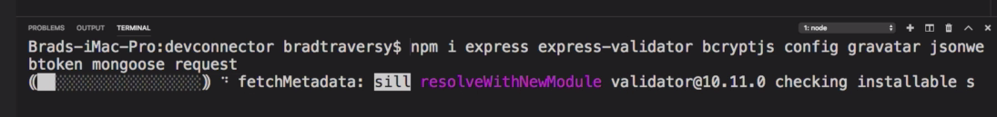

1. Dev dependencies:

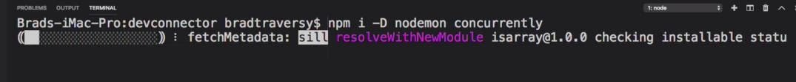

CREATE SERVER

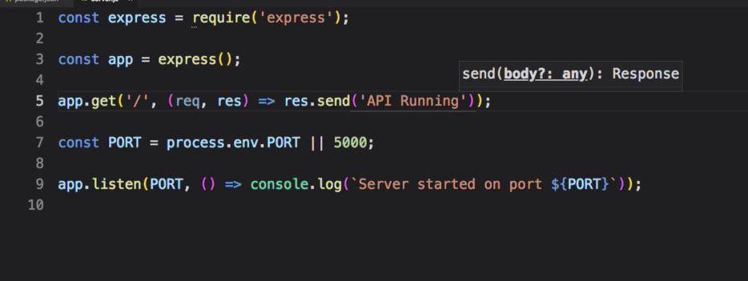

For running in package.json we change the scripts like this:

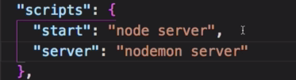

Create a commit:

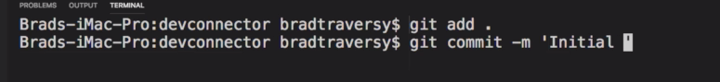

# Connect to DB

Create the default.json file on a new folder called config to keep all our global values.

On that file we paste our URI from Atlas DB.

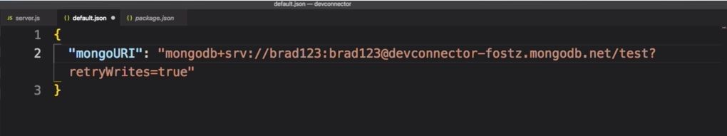

Then, we create a new file called db.js with our connection function.

